JANTA VIDYA MANDIR GANPATRAI RASIWASIA COLLEGE, CHARKHI DADRI
Faculty Profile

Department--- Chemistry

Name of Faculty |  | Dr. Arun Kumar |  |  | 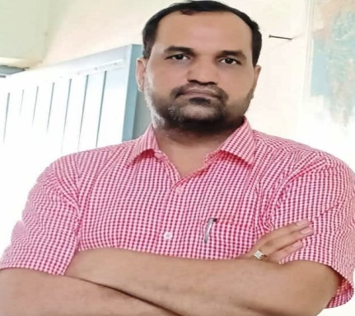
Department |  | Chemistry
Designation |  | Assist. professor
Experience |  | 11.5 Years
Contact No |  | 9518897777
Email Id |  | 7077arun@gmail.com
Date of Joining |  | 01-07-2013
Educational Qualification
 | Name of Program |  | Year of  Passing | University
PG | M.Sc. Chemistry |  | 2008 | M. D. University, Rohtak
Ph.D. | Inorganic Chem. |  | 2019 | Singhania Univ., Rajasthan
Net | CSIR |  | 2008 | CSIR- Net Jrf
Other
Research Supervision/Guidance |  | -
Research Publications |  | 04
Books Published |  | -
Book Chapters |  | -
Papers Presented in Conferences/ Seminar |  | International: 04 National: 06
Participated in Conferences/ Seminar |  | International: 06 National: 10
No. of Workshops/FDP/Training Programme Attended |  | 04
Major/Minor Research Projects |  | -
Invited Lectures |  | -
Awards/ Honours |  | -
Membership of Any  Professional/ Statutory Body |  | -
Any Other Achievement |  | -

