JANTA VIDYA MANDIR GANPATRAI RASIWASIA COLLEGE, CHARKHI DADRI
Faculty Profile

Department of Physical Education

Name of Faculty |  | Dr. Bhupender Singh |  |  | 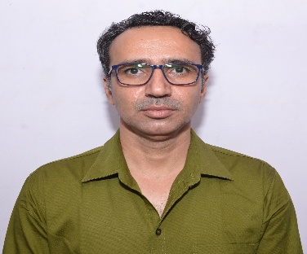
Department |  | Physical Education
Designation |  | Associate Professor
Experience |  | 16 years
Contact No |  | 7082460234
Email Id |  | bhupenderjvm@gmail.com
Date of Joining |  | 12 July 2008
Educational Qualification
 | Name of Program |  | Year of  Passing | University
PG | M.A |  | 2002 | M.D.U. Rohtak
Ph.D. | Physical Education |  | 2013 | M.D.U. Rohtak
Net | Physical Education |  | 2006 | U.G.C
Other | M.Phil |  | 2007 | K.U. Kurukshetra
Research Supervision/Guidance |  | N/A
Research Publications |  | 10
Books Published |  | 1
Book Chapters |  | N/A
Papers Presented in Conferences/ Seminar |  | International:2 National:9
Participated in Conferences/ Seminar |  | International:2 National:9
No. of Workshops/FDP/Training Programme Attended |  | 10
Major/Minor Research Projects |  | N/A
Invited Lectures |  | 2
Awards/Honours |  | N/A
Membership of Any  Professional/ Statutory Body |  | - Board of Studies, CBLU Bhiwani  - Sports Council, CBLU, Bhiwani  - Convener, Selection Committee of CBLU, Bhiwani in Athletics, Cross country, Kho-Kho, Football, Swimming,Kabaddi.
Any Other Achievement |  | National level Athlete.

