JANTA VIDYA MANDIR GANPATRAI RASIWASIA COLLEGE, CHARKHI DADRI
Faculty Profile

Department: PHYSICS

Name of Faculty |  | Dr. JAIVIR SINGH |  |  | 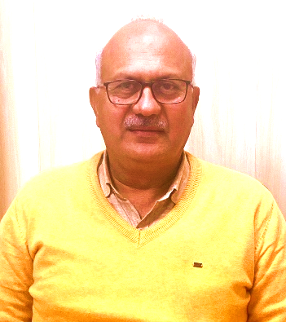
Department |  | PHYSICS
Designation |  | ASSOCIATE PROFESSOR & HEAD
Experience |  | 28 years 6 months
Contact No |  | 9416231096
Email Id |  | jsuhag.123@gmail.com
Date of Joining |  | 16/12/1996 (Ad hoc) 12/12/1998 (on Regular Basis)
Educational Qualification
 | Name of Program |  | Year of Passing | University
PG | M. Sc. Physics |  | 1993 | M.D. University, Rohtak
Ph.D. | Dept. of Physics |  | 2022 | B.M. University, Rohtak
Net | Physics |  | 1994 | UGC-CSIR (Delhi)
Other | - |  | - | -
Research Supervision/Guidance |  | One Scholar Pursuing
Research Publications |  | 18 (6 UGC Care Listed, 12 peer reviewed Open Access International Journals)
Books Published |  | 13
Book Chapters |  | -
Papers Presented in Conferences/ Seminar |  | International: 04 National: 07
Participated in Conferences/ Seminar |  | International: 01 National: 03
No. of Workshop/ FDP/Training Program Attended |  | 06
Major/Minor Research Projects |  | -
Invited Lectures |  | Eighteen
Awards/Honours |  | -
Membership of Any  Professional/ Statutory Body |  | Lifetime member of Indian Association of Physics Teachers (IAPT)  Subject Expert with HBSE, Bhiwani  Panelist on Examination board, HBSE, Bhiwani  Subject Expert with Indira Gandhi University, Meerpur  Subject Expert with CBLUniversity, Bhiwani  Member ‘Board of Studies’ for Physics and Integrated courses with CBL University, Bhiwani
Any Other Achievement |  | Organising Secretary for National Seminar on Scientific Developments for Human Welfare: Promises and Concerns (2012)  Observer, National Standard Examinations (2019 and 2024) conducted by IAPT.  Convener-3rd International Conference on Recent trends in Material Science *& Devices (24-26 March’ 2025) ICRTMD

