JANTA VIDYA MANDIR GANPATRAI RASIWASIA COLLEGE, CHARKHI DADRI
Faculty Profile

Department-Chemistry

Name of Faculty |  | Dr Jitender Kumar |  |  | 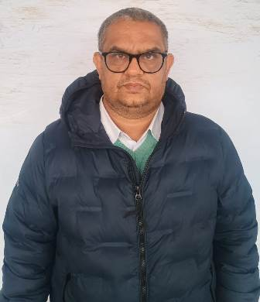
Department |  | Chemistry
Designation |  | Associate Professor
Experience |  | 16 years 6month
Contact No |  | 8396030274
Email Id |  | Jitendernarwal08@gmail.com
Date of Joining |  | 14-07-2008
Educational Qualification
 | Name of Program |  | Year of  Passing | University
PG | Chemistry |  | 2004 | MDU ROHTAK
Ph.D. | Chemistry |  | 2011 | MDU ROHTAK
Net | Chemistry |  | 2005 | CSIR
Other
Research Supervision/Guidance
`
Research Publications |  |  | 11
Books Published |  |  | 07
Book Chapters
Papers Presented in Conferences/ Seminar |  |  | International:12 National:30
Participated in Conferences/ Seminar |  |  | International:03 National:24
No. of Workshops/FDP/Training Programme Attended |  |  | 04
Major/Minor Research Project
Invited Lectures |  |  | 06
Awards/Honours

Membership of Any  Professional/ Statutory Body |  |  | Indian Science Congress Association, Indian Council of Chemists, Indian Thermo dynamical Society,
Any Other Achievement

