JANTA VIDYA MANDIR GANPATRAI RASIWASIA COLLEGE, CHARKHI DADRI
Faculty Profile
Physics
Department

Name of Faculty |  | Dr.Vipin pal singh |  |  | 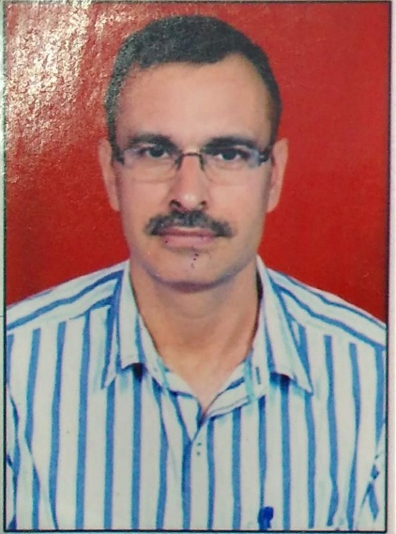
Department |  | Physics
Designation |  | Associate Professor
Experience |  | 18 year
Contact No |  | 9991908180
Email Id |  | Vipin78pilania@gmail.com
Date of Joining |  | 20.01 2007
Educational Qualification: M.sc, M.Phil ,Ph.D

 | Name of Program |  | Year of  Passing | University
PG | MSc Physics |  | 1999 | Kurukshetra University
Ph.D. | Ph.D |  | 2016 | Singhania University Rajasthan
Net | Physical Sciences |  | 2000 | CSIR
Other | MPhil |  | 2009 | Vinayaka Mission University Salem,  Tamilnadu
Research Supervision/Guidance |  | NA
Research Publications |  | 6
Books Published |  | NA
Book Chapters |  | NA
Papers Presented in Conferences/ Seminar |  | International:2 National:17
Participated in Conferences/ Seminar |  | International: 2 National:17
No. of Workshops/FDP/Training Programme Attended |  | -8
Major/Minor Research Projects |  | NA
Invited Lectures |  | NA
Awards/Honours |  | NA
Membership of Any  Professional/ Statutory Body |  | 1.Board of Studies CBLU Bhiwani  2The Indian Science Congress Association
Any Other Achievement

